PROJECT DEVELOPMENT PHASE 7
UAT, Documentation & Deployment
Script-Controlled ACL – Restrict Record Access Based on Field Value
Project Details | Values
Date | 30 September 2026
Team ID | SWTID-2026-8983
Project Name | Script-Controlled ACL – Restrict Record Access Based on Field Value
Phase | Phase 7 – UAT, Documentation & Deployment
Maximum Marks | 5 Marks

Team Role | Team Member
Team Leader | NITHYA SREE S
Team Member | RAMASRI D
Team Member | PRATHISHA S
Team Member | MEGALA M
Team Member | MANJARI T

1. Objective
Obtain user acceptance, document the final access behavior, and deploy the approved ACL through change control.

2. Phase Workflow
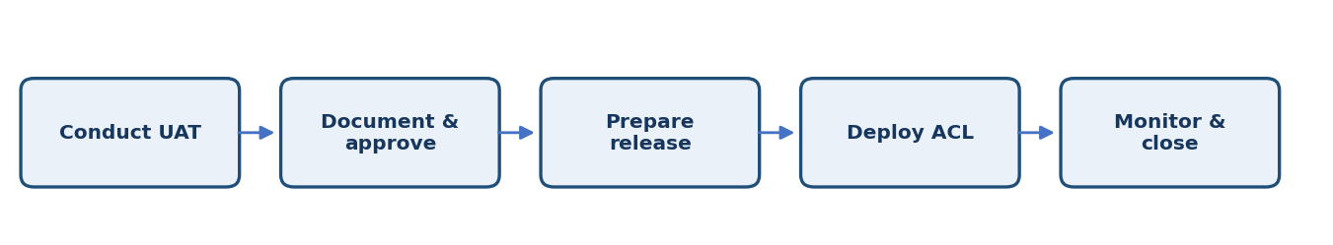

3. Activities / Scope
- Demonstrate the access rules to the project owner or representative users.
- Capture UAT results, approvals, and any known limitations.
- Prepare deployment steps, dependencies, and rollback plan.
- Move the approved ACL through the team's release process.
- Monitor access after deployment and document closure.

4. Sprint Backlog & Estimation
Sprint | Story ID | Requirement | User Story / Task | Story Points | Priority | Team Members
Sprint 7 | US-701 | Conduct UAT | Validate the access matrix with intended users. | 2 | Medium | Project Team
Sprint 7 | US-702 | Prepare release | Document deployment and rollback steps. | 2 | Medium | Project Team
Sprint 7 | US-703 | Deploy and monitor | Release approved changes and check behavior. | 3 | High | Project Team

Total Estimated Story Points: 7

5. Testing / Review Template
Test Case ID | Scenario / Steps | Expected Result | Actual Result | Status
TC-01 | Complete UAT with representative users, verify the production behavior after release, and record any follow-up actions. | Expected behavior matches approved requirement. | ________________ | Pass / Fail
TC-02 | Record observations, issues, and evidence for this phase. | No unresolved blocker before phase sign-off. | ________________ | Pass / Fail
TC-03 | Review phase deliverables with the responsible team member. | Deliverables reviewed and approved. | ________________ | Pass / Fail

6. Deliverables
- UAT report
- Final technical documentation
- Deployment and rollback plan
- Release sign-off

7. Team Review & Sign-off
Review Item | Details
Prepared by | Megala M / Project Team
Reviewed by | ____________________________
Approval / Date | ____________________________
Remarks | ________________________________________________

